4 HEART AND BLOOD
TASK 1

INTRODUCTION
Hematology is the study of blood. The adult cardiovascular system contains approximately 5.5L of blood. Blood is a connective tissue composed of a variety of cells suspended in a liquid matrix, plasma.
Plasma comprises about 55% of whole blood volume and is approximately 91.5% water and 8.5% solutes. The solutes are mostly plasma proteins, but also include nutrients (glucose, amino acids and lipids), blood gases (oxygen and carbon dioxide), electrolytes, hormones, enzymes and waste products.
The cells constitute about 45% of whole blood and include red blood cells
(erythrocytes), white blood cells (leucocytes) and platelets (thrombocytes). Blood cells are difficult to see at low magnifications (<x1000) because the cells are so small.
The most numerous blood cells are the circulating red blood cells
(c.5 x 10¹² /L).Their function is to transport oxygen. They are small, biconcave, pinkish cells that have no nucleus.
The white blood cells are not very numerous but are easier to see as their nuclei stain dark blue/purple with Giemsa stain and most of them are larger than red blood cells. There are five different types of white blood cell divided into two categories depending on whether they have granules or not in their cytoplasm.
They are vital to our defence against infections.
Leucocytes
Granular | Neutrophils | Eosinophils | Basophils
Agranular | Lymphocytes | Monocytes
Platelets are tiny (150 000 - 400 000/ml circulating blood) and are dispersed among the cells. They stain dark purple and may appear to you as extra stain on the slide.

IDENTIFICATION OF BLOOD CELLS AND PLATELETS
In this experiment the light microscope will be used to observe pre-prepared slides of blood samples.
When viewing blood slides it is important to remember that the cells and the nuclei have a 3-dimensional spherical shape so you will not always see the nucleus appearing as described or seen in photomicrographs because of the various views that are possible.

PROCEDURE
- You are provided with a pre-prepared slide of normal human blood. Use the low power lens to locate red and white blood cells.
- Using the high-power or oil-immersion lens, locate white blood cells and platelets.

RESULTS
- Draw or insert observed pictures under the microscope of the field of view (to include two different types of white blood cell), on the following pages.
- To identify the white blood cell type, refer to the following pages.
- Look at the size of the cell compared with red blood cells, the presence of granules, the shape and number of lobes to the nucleus. Identify the cytoplasm, plasma membrane and any other structures observed.

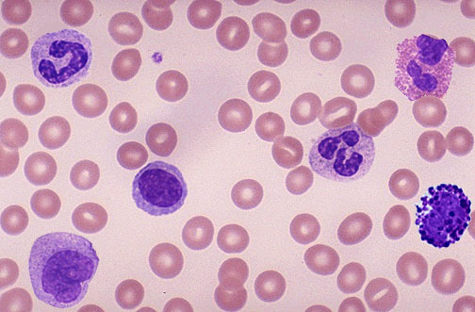
Ans:1
Cytoplasma

Neutrophil
Lymphocyte

There are two different types of White blood cells: Neutrophil and Lymphocyte

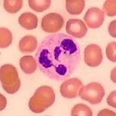 NEUTROPHIL (granular)
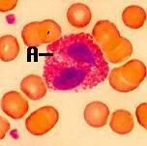 EOSINOPHIL (granular)
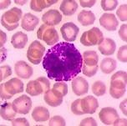 BASOPHIL (granular)
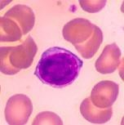 LYMPHOCYTE (agranular)

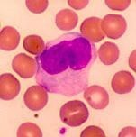 MONOCYTE (agranular)

DIFFERENTIAL WHITE BLOOD CELL COUNT
A differential white blood cell count is performed to determine the percentage of each of the five types of white blood cells in a blood sample. As the normal percentage of each is known, any significant deviance from these, elevated or depressed, can be indicative of a particular disorder.
By referring to the previous page, you should be able to easily identify the white blood cells (leucocytes) as you see them on the slide.
This activity should be carried out with a partner. One person will identify each white blood cell with the microscope and inform the partner who is responsible for recording the type of cell and the number counted.

PROCEDURE
- Using a prepared, normal blood slide, focus using the low power lens and then switch to a high power lens.
- Count the white blood cells according to the following procedure –
Begin at one end of the slide that has a good separation of cells and slowly scan systematically, moving the slide down and over, then up and over, and repeat as shown below:
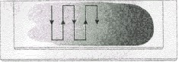
If you encounter a cell that you cannot identify or are not sure of, do not count it and continue on.
- Continue with this pattern until you have found and recorded 100 white blood cells in total.
- Write your results on the board to pool class data.
- Complete a differential white blood count using a prepared slide of abnormal blood following the directions above and pool class data for comparison as before.

RESULTS
Present your results in two tables, one for normal blood and one for leukaemia blood using the following:
Normal Differential White Blood Cell Count
Type of white blood  cell | Granular/ Agranular | Observation  tally | Percent- age | Class percent- age | Variation from Class  %  (Personal %  + or -) | Normal percentage of white blood cell
Neutrophil | Granular | |||| |||| |||| |||| |||| ||||  |||| |||| |||| |||| || |  |  |  | 60-70%
Lymphocyte | Agranular | |||| |||| |||| |||| |||| |  |  |  | 20-25%
Monocyte | Agranular | |||| |||| |||| ||| |  |  |  | 3-8%
Eosinophil | Granular | |||| |  |  |  | 2-4%
Basophil | Granular | 0 |  |  |  | 0.5-1%

Were your results within the values expected? Leukemia Differential White Blood Cell Count
Type of white blood  cell | Granular/ Agranular | Observation  tally | Percent- age | Class percent- age | Variation from Class  %  (Personal  % + or -) | Normal percentage of white blood cell
Neutrophil | Granular | |||| |||| |||| |||| |||| | |  |  |  | 60-70%
Lymphocyte | Agranular | |||| |||| |||| |||| |||| |||| |  |  |  | 20-25%
Monocyte | Agranular | |||| |||| || |  |  |  | 3-8%
Eosinophil | Granular | |||| |  |  |  | 2-4%
Basophil | Granular | |||| |||| |||| |||| |||| ||| |  |  |  | 0.5-1%

DISCUSSION
- Were your results within the values expected?
Ans: From the above table we observed the normal differential White Blood Cell count are:
Neutrophils: It is slightly below the normal range. The normal range is (60%-70%) but we get 52% which is lower than expected.
Lymphocytes: It is with the normal range.
Monocytes: Its value is elevated from normal range. The normal range is (3-8%) we get 18% which is higher than expected.
Eosinophil: It is slightly elevated from the normal range. The normal range is (2-4%) but we get 5% which is higher than expected.
Basophil: Its value is below the normal range. The value is zero.
From the above table the leukemia differential White Blood Cell count are:
Neutrophils: It is significantly below the normal range. The normal value is (60-70%) but we get 26% which is higher than expected.
Lymphocytes: Its value is slightly elevated from the normal range. We get the value 29% which is higher than expected.
Monocytes: It is elevated above the normal range. The normal range is (3-8%) we get 12% which is higher than expected.
Eosinophil: Its value is slightly elevated above the normal range. The normal range is (2-24%) we get 5% which is higher than expected.
Basophil: Its count is significantly elevated above the normal range. The normal range (0.5-1%) but we get 28% which is higher than the normal range.
In conclusion, abnormal white blood cell (WBC) differentials can reveal numerous conditions. In leukemia, there typically will be a gross deviation from normal. However, as with all such studies, it's very important to note that WBC differentials by themselves are not diagnostic of leukemia; one would need a comprehensive evaluation by a doctor to truly diagnose and treat it.

- Discuss the role of both red and white blood cells in relation to their concentration in normal blood.
Ans: Normal blood contains many red blood cells yet white blood cells stay at lower levels because their essential tasks differ from each other.

The blood shows red blood cells as its main cellular element that occupies between 40–45% of the total blood volume measured by hematocrit. The principal duty of red blood cells entails moving oxygen from lungs to organs through blood circulation while returning carbon dioxide for lung exhalation. The oxygen-binding capability of red blood cells stems from the iron protein hemoglobin present inside them. The oxygen transportation service and organ energy preservation needs create an essential requirement for the high red blood cell presence that characterizes regular blood.

The immune defense depends on white blood cells as blood contains only 1% white blood cells in lower numbers than other blood cell populations. White blood cells function as protective agents within the human body while fighting against infectious agents and both abnormal cellular growths and cancerous cells. White blood cells exist in a limited volume which consists of neutrophils along with lymphocytes and also monocytes and eosinophils and basophils. Rapid bacterial infection defense functions belong to neutrophils while lymphocytes control viral infections by building immune defense systems.

Red blood cells exist in large numbers to support their oxygen transportation functions yet white blood cells demonstrate disease-fighting capabilities through an overall low but varied population.

- Suggest possible reasons for the differences in your findings between the leukemia differential white blood cell count and the normal differential white blood cell count.
Ans: The differences of the normal and leukemia differential white blood cell count may be able to describe the way in which leukemia affects white blood cell production and balance of the body. As a whole, leukemia is an informal term that denotes a collection of cancers that form in the bone marrow where blood is produced. Leukemia causes producing excess abnormal amounts of white blood cells; the excess is not a good thing because it will drive out the normal, healthy cells. The abnormal white blood cells might not work very often, but they do register on a white blood cell count. This can also contribute to alterations in the white blood cell ratio of different kinds. In this data set, there is a prominent increase in lymphocytes and basophils in leukemia sample compared to normal sample. This may indicate that there is a type of leukemia that is producing lymphoid cells (e.g., lymphocytic leukemia) producing immature or abnormal lymphocytes in increasing numbers. Although the basophils are within the normal range, an increase in basophils might suggest some stimulation of the bone marrow or immune system imbalance because these tend to be present along with some types of leukemia.
Even though the total percentage of some of the cells (e.g., neutrophils and monocytes) is within the normal limit, the differences from each class mean shows the way leukemia can have a more subclinical, subtle, or restricted effect on the white blood cells of different types.

Task 2

INTRODUCTION
The cardiovascular system consists of the heart, the blood vessels and the blood. In order for blood to reach the body cells and exchange materials with them, it must be constantly propelled through the blood vessels. The heart is the pump that circulates the blood through a network of blood vessels, (estimated to be 100 000km), beating about 100 000 times every day.
Most of the heart is composed of cardiac muscle, a specialised tissue that contracts automatically, powerfully and without fatigue, which ensures a constant supply of blood to the body and lungs.
The heart itself is actually two separate pumps lying side by side. Humans, like mammals, have a double circulation and this arrangement means that the blood from each circulatory system does not mix:
The Pulmonary circulation - carries deoxygenated blood from the heart to the lungs
The Systemic circulation - carries oxygenated blood from the heart to the rest of the body
Each side of the heart has two chambers, an atrium and a ventricle.
Blood is received into the atria and pumped out by the ventricles. The right side receives deoxygenated blood and the left side oxygenated blood. It is important that blood flow is in one direction only and backflow is prevented by the presence of valves between the atria and ventricles and at the openings to the arteries carrying blood away from the heart.
The following practical examines the structure of the heart as a whole and the differences between the chambers, valves and vessels in relation to their function.

PROCEDURE
1. Inspection of the heart and exterior anatomy
- Obtain a dissecting tray, tools, disposable gloves and a heart.
- Examine the anterior surface of the heart.
(Great vessels are often cut close to the base of the heart and may be difficult to find).
Refer to the resources provided to identify the following structures:
  - Pericardium (if present)
  - Apex
  - Right atrium
  - Left atrium
  - Right ventricle • Left ventricle
- Examine the posterior surface of the heart.
Identify the following structures:
  - Coronary sulcus
  - Aorta
  - Left atrium
  - Left ventricle
  - Right atrium
  - Right ventricle
- Examine the interior of the heart by making a coronal section of the heart. This is achieved by using a knife starting at the apex and cutting towards the base. Do not cut the heart completely in half but open out so that both atria and ventricles can be observed and compared.
Identify the following structures on the right side of the heart:
  - Right atrium
  - Opening of superior and inferior vena cava
  - Tricuspid valve
  - Right ventricle
  - Chordae tendinae
  - Pulmonary semilunar valve
- Identify structures on the left side of the heart:
  - Left atrium
  - Bicuspid valve
  - Left ventricle
  - Aortic semilunar valve
  - Aorta
When you have finished dispose of the dissection material in the bag provided (not the sink!)
Wash your hands.

RESULTS
From your observations label the parts of the heart on the following diagrams using the list below. Label all diagrams as fully as possible.
Coronary Arteries
Carotid Arteries
Aortic Arch
Superior Vena Cava
Inferior Vena Cava
Left Ventricle
Right Ventricle
Left Atrium
Right Atrium
Tricuspid Valve
Bicuspid Valve
Pulmonary Valve
Aortic Valve
Interventricular Septum
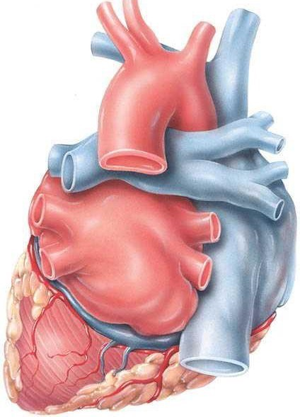
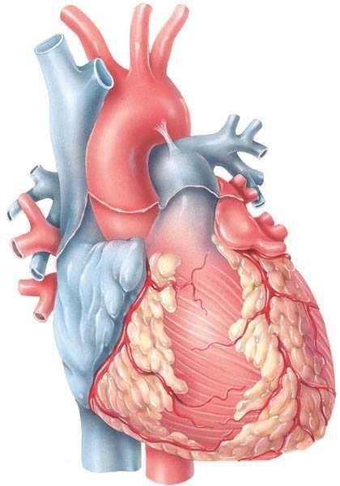
Right ventricle
Left ventricle
Left pulmonary artery
Left pulmonary vein
Right pulmonary vein
Right pulmonary artery
Superior vena cava
Inferior vena cava
Inferior vena cava
Left coronary artery
Right coronary artery
Superior vena cava
Right common carotid artery
Left common carotid
artery
Aortic arch
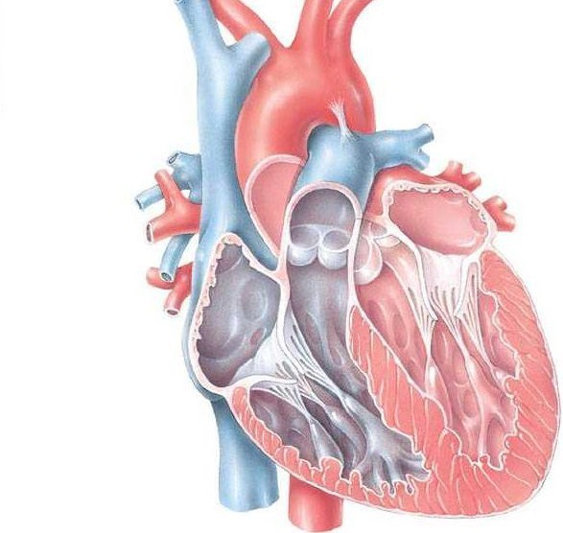
Interventricular septum
Right ventricle
Tricuspid
valve
Right artium
Left artium
Left ventricle
Bicuspid valve
Aortic valve
Pulmonary valve

DISCUSSION
- Starting with the superior vena cava and using the following structures, create a flow diagram showing blood movement from the neck area to the heart, the lungs, and out of the heart to the systemic circulation. Draw this pathway in the space provided below. You do not need to draw structures.
• | aorta | • | pulmonary capillaries | • | pulmonary valve
• | tricuspid valve | • | right atrium | • | pulmonary veins
• | bicuspid valve | • | right ventricle | • | superior vena cava
• | left atrium | • | pulmonary arteries
• | left ventricle | • | aortic valve

Ans: Flow diagram of heart

Superior Vena Cava
↓
Right Atrium
↓
Tricuspid Valve
↓
Right Ventricle
↓
Pulmonary Valve
↓
Pulmonary Arteries
↓
Pulmonary Capillaries (Gas exchange occurs here)
↓
Pulmonary Veins
↓
Left Atrium
↓
Bicuspid Valve
↓
Left Ventricle
↓
Aortic Valve
↓
Aorta
↓
Systemic Circulation (throughout the body)

- Where is the muscle of the heart strongest, how can you tell?

Ans: The left ventricle occurs as the most powerful heart muscle. The wall thickness of this chamber reveals the power, it needs to maintain high pressure for circulating oxygen-rich blood to the entire body through the aorta.

3.How does the heart prevent blood flowing in the wrong direction?
Ans: The heart has four main valves in the heart ensure that blood only flows in one direction:
1.Between the right atrium and right ventricle is the tricuspid valve.
2. The pulmonary valve, which separates the pulmonary artery from the right ventricle
3. The mitral (bicuspid) valve, which separates the left atrium from the left ventricle.
4. Aortic valve, which separates the aorta from the left ventricle
They open when the heart muscle contracts to push the blood forward and close when the heart muscle relaxes to keep the blood from flowing backward. The one-way flow under pressure is made possible because of the structure of these valves, which includes supporting chordae tendineae (heart strings) and cusps (flaps).
4.How does the heart muscle itself receive oxygen for respiration?
Ans: The coronary arteries provide oxygen to the heart muscle. These arteries, separating from the aorta, supply oxygenated blood to the myocardial (heart muscle). While the right coronary artery provides blood to the right ventricle and atrium, the left coronary artery divides into the left anterior descending and circumflex arteries. The heart muscle gets oxygen and nutrients at the capillary level, and deoxygenated blood is drained back to the right atrium through the coronary veins. Heart damage and diminished oxygen supply may be brought on by blockage of these arteries.

